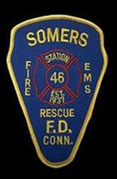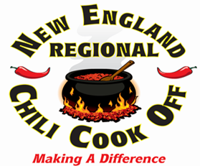

Your sponsorship will help assure the success of The New England Regional Chili Off on May 5, 2018 at Sonny’s Place.
Your generous contribution to the event can be highlighted in a number of ways.
Thank you for support.
Silver Sponsorship $250.00
Your company/name will be posted at the event with appropriate mentions via public address at the event as well as being listed on the chilict.com site. Showcase your business in the highly visible “sponsor row” by confirming a 10 x 10 space; 2 entry event tickets; numerous mentions via public address at the event as well as being listed on the chilict.com site. Additionally, you may submit up to 4 representatives to participate in the ICS judging. Your team is also invited to prepare your “best chili” to serve to the public. If you are interested in competing at the ICS level, contact our chairman, Michael Freedman.
Gold Sponsorship - $500.00
Your company/name will be posted at the event with appropriate mentions via public address at the event as well as being listed on the chilict.com site. Showcase your business in the highly visible “sponsor row” by confirming a 10 x 10 space; 4 entry event tickets; numerous mentions via public address at the event as well as being listed on the chilict.com site. Additionally, you may submit up to 4 representatives to participate in the ICS judging. Your team is also invited to prepare your “best chili” to serve to the public. If you are interested in competing at the ICS level, contact our chairman, Michael Freedman.
Platinum Sponsorship - $1000.00
Showcase your business in the highly visible “sponsor row” by confirming a 10 x 10 space; 8 entry event tickets, numerous mentions via public address at the event as well as being predominately displayed on the chilict.com site. Additionally, you may submit up to 6 representatives to participate in the ICS judging. Your team is also invited to prepare your “best chili” to serve to the public. If you are interested in competing at the ICS level, contact our chairman, Michael Freedman.

Major Sponsor $2500.00+
Showcase your business in the highly visible “sponsor row” by confirming a 10 x 10 space; 12 entry event tickets; numerous mentions via public address at the event, included in all media coverage as well as being predominately displayed on the chilict.com site. Additionally, you may submit up to 10 representatives to participate in the ICS judging. Your team is also invited to prepare your “best chili” to serve to the public. If you are interested in competing at the ICS level, contact our chairman, Michael Freedman.

Sponsorships are tax deductible. For more information, please contact: Michael Freedman 860-324-3287 or email: madmike@chilict.com

Agreement
__________ Major Sponsor $2500
__________ Platinum Level Sponsor $1000.00
__________ Gold Level Sponsor $500.00
__________ Silver Level Sponsor $250.00
__________ Please accept my charitable donation in the amount of $ __________ in support of this event.

Please return this form with your check made payable to SFD
Send to: SFD 400 Main St, Somers, CT 06071
Attn: Marybeth Marquardt

Company Name _______________________________________________________
Contact Name _______________________________________________________
Address _______________________________________________________
Phone _______________________ Fax ______________________
Email Address ___________________________________________
__Yes __No 10x10 space in sponsor row

__Yes __No We will have representatives for ICS Judging

__Yes __No We will be preparing chili to serve to the public

Signature _______________________________________________ Date__________

